GregsList

Riley Pittman
Rohith Pottabathni
Henry Ho
Abhinav Vora

Goals of the project

Searching for specific items on craigslist is a tedious task. This task is composed of two things: Finding an item that is acceptable to the user on the parameters of quality and price, and then finding something that is within a certain distance of the users location. Craigslist also has a fast turnaround time for listings, hence the user needs to be constantly checking it. The goal of the Greg’s list project was to make finding items from Craigslist easier using the following features:
- Find items and be able to filter on price, location and recency of posting
- Be automatically notified of new postings that match the users criteria
- Be able to view the rating of the product on the same site
- Be able to visually view postings by area
- Build a customized route to visit all items that the user wishes to view

Choice of routing algorithm:

The map functionality lets the user add items of interest to the map and then then generates directions to navigate through them all. The user has the option to provide the starting address. If the starting address is not provided, the first item that was added to the route is used as the starting point.
We first implemented a naïve routing algorithm that would use the order in which the user added items to the map as the sort order for addresses. So even if the user might add an address that is further than his current location first, this algorithm would first pick that address. We then implemented a smarter algorithm that uses the user specified starting address but then finds the closest location to that address before generating directions. We used the Haversine formula to calculate the straight line distance between two points when sorting the list of addresses the user wants to visit.
We considered alternative ways to sort addresses such as quality of product (route to the closest product that is also the best rated), price (route to the closest listing that is also the cheapest), etc. However, these appear arbitraty and would need to be validated by doing user studies to get feedback. It is easy enough to add this functionality if user preference could be predicted.
Screen shots
Viewing all postings on a map:

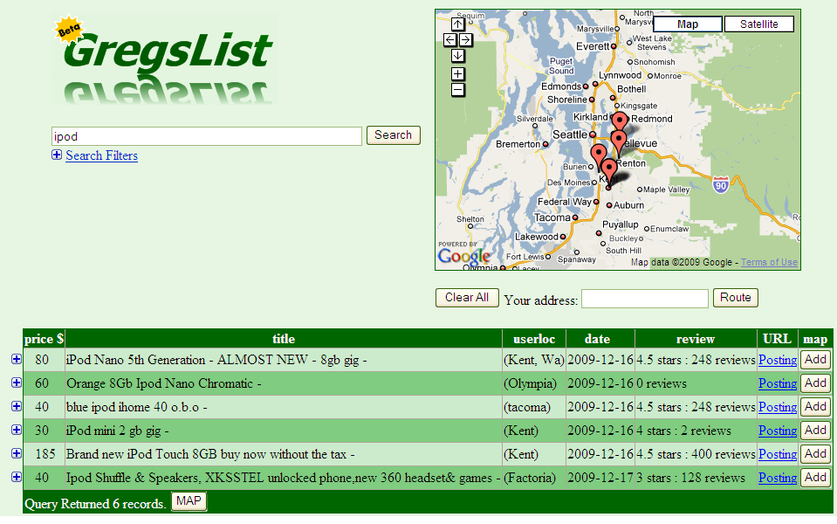

Building your own route map:

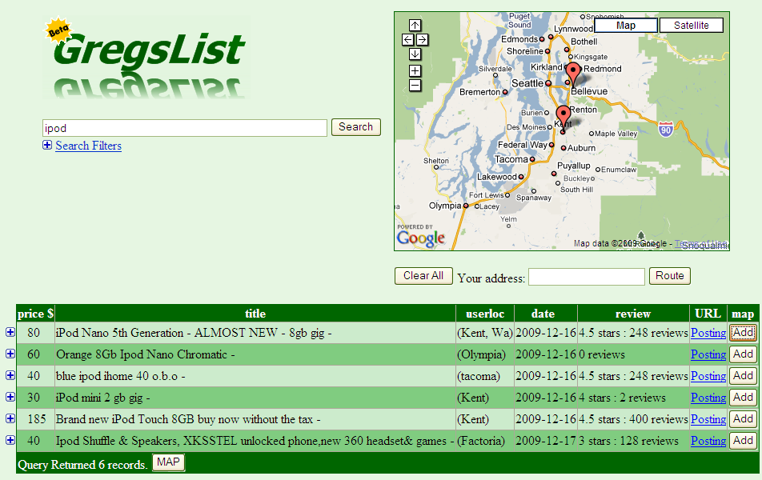

Finding best route for chosen items: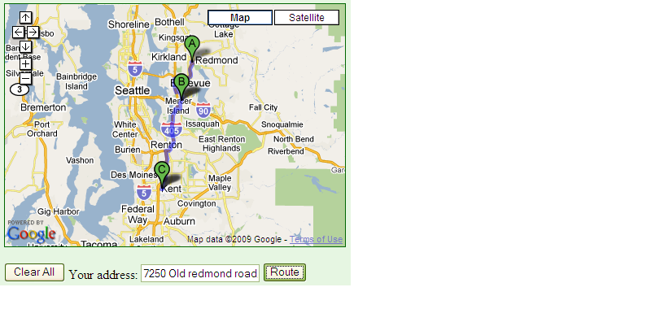

Prior to taking the class we didn’t have any experience with web programming. We learned the HTML, JavaScript, AJAX, PHP, and Google Products and Maps API that we used to make our site as we went. We learned some of the API for Google Maps, such as being able make a map and insert points onto it, to route based on shortest distance, and get the coordinates of a named location. We learned how to use CSS and JavaScript to make the UI better looking. We learned how to use PHP to communicate with our MySQL database and then to generate the tables that display our queries dynamically.
Outside of learning new languages and APIs, we also learned how difficult it can be to get something to work cross-browser. It was surprising to find out that alerts only worked in FireFox or that FireFox and IE had different methods of centering div tags. We also ran into problems with having so many programming languages communicating with one another. One issue that was surprising was that special characters had to be escaped when going through Java, then Java’s regex function, and then MySQL. In one case we needed “\\\\\” to denote don’t treat “\” as a special character when putting a string into a table. It was also surprising how different debugging our project was from our previous projects. Oftentimes we had a hard time debugging our program as we didn’t have access to error logs on cubist and we couldn’t get errors to output directly to our screens; all we had to go on was the fact that our website wasn’t working.

There are a lot of things we would do differently if we did this over again. First, getting a very clear and concrete goal for our project would have made this project a lot better. We could have focused entirely on one aspect of our project and made that one thing amazing instead of spreading out our efforts into multiple tasks. Setting up SVN and daily backups of our database would have saved us a lot of time. SVN would have helped both in figuring out what changes another person made to a file and in recovering an old version of a file when a change we made caused our code to break. Daily backups of our database would have helped a lot as our cleaner ended up deleting our entire table of information and we have to use older table of data. One major issue we kept running across was that the data in our database kept needing modifications. Either there wasn’t enough detail to the data and we needed to remake our table, or the data we had in the data was no longer useful, such as the post was deleted. If we could do it over, we’d try to get a database full of good data that we wouldn’t need to later change as soon as possible, so that we could work on our project without interruption. Coding-wise we would definitely not use text files as our way of saving search results and find a way to avoid using Java altogether. Instead of processing SQL queries with Java to get the results we wanted, we would use more complicated SQL queries that would do the processing. All these changes would result in cleaner, faster code. We also would have used the Google Products Search API instead of directly sending queries to the page, which at the time we did not know existed.

We ended up accomplishing all of the things that we had set out to do in our project. It has a map feature that allows us to see the general area of where our items are located, as opposed to having to look at every search item, and interpreting whether “u village”, “north seattle”, or “u-dist” were places we are willing to go to buy that item. We also added useful improvements to how CraigsList displays their information, by allowing a user to filter on many different things and also to preview and compare different pages. We added something that notified the user of when there were new, relevant results for their search queries. However, the end product does not work perfectly and does not go deeply into any one of our goals. In the future, we could improve upon any one of these aspects of our project. For the location aspect, we could extract addresses when they exist and use those for more exact locations of where an item is. If no location is given, we could try to guess the location by extracting a phone number and using the area code as an estimate of location. Getting driving directions to a particular location would also be useful. We could also improve the accuracy of our review finder by using the text/pictures in the post to determine the product or by crawling the internet for reviews as opposed to using Google Products. Another idea is to make a Windows 7 gadget or expand our project to include all the products on CraigsList. Overall, there is a lot more that we can do with this project in the future.

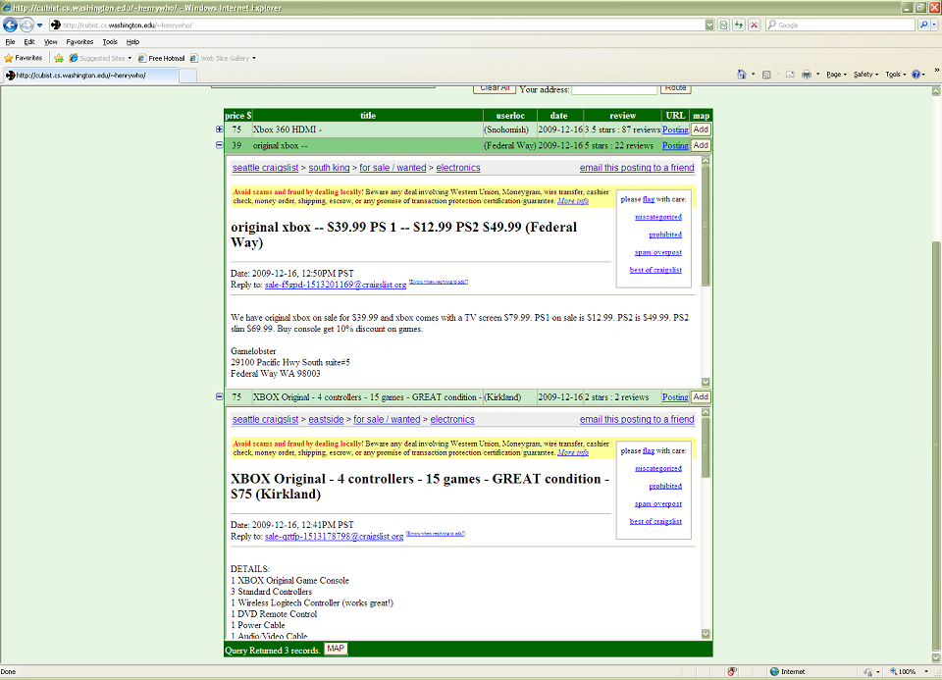

By clicking on the expand icon next to a post, a user can view the post. Multiple posts can be expanded and compared, as shown above.
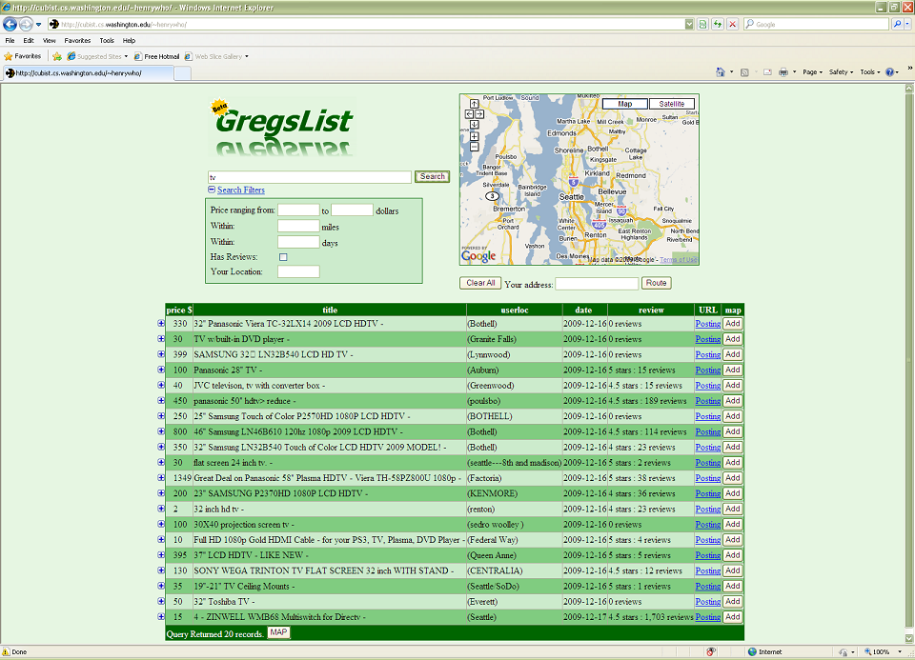

This is a search for TVs without using filters.
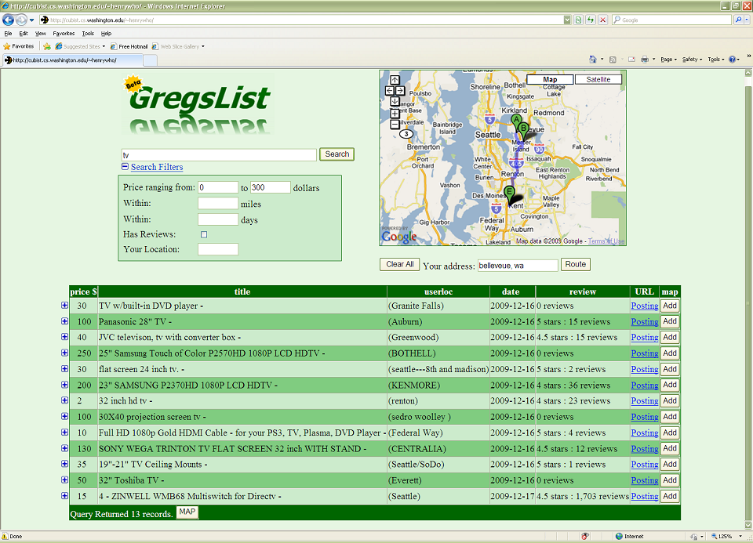

Here is the same query after filtering the results to show only TVs in the price range of 0 to 300 dollars.
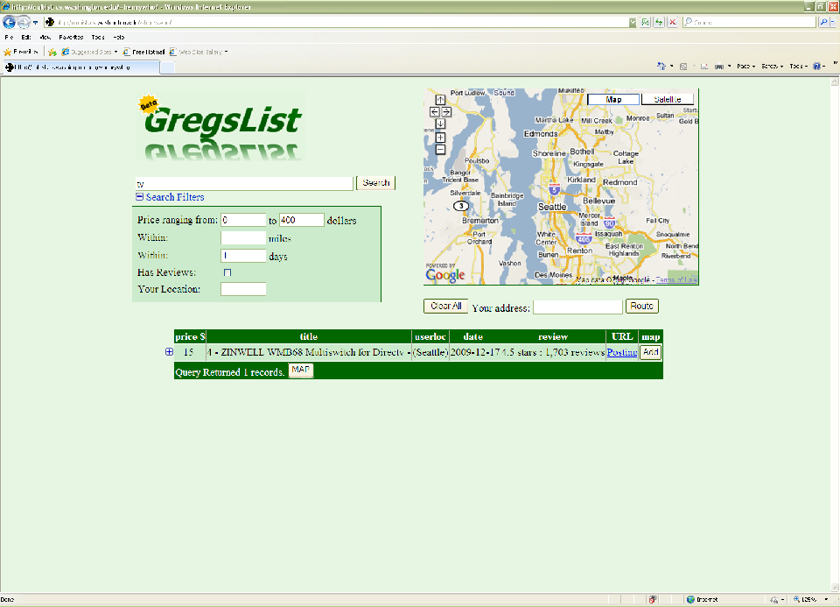

This is the result of searching for TVs that were posted in the past day.

System Design

Our system design can be divided into four operations : gathering the data, cleaning the data, querying the data, and displaying the data.

In order to gather our data from CraigsList and Google Products we utilized the java wget class. We called wget on the electronics page from CraigsList Seattle and using the source of that page, we crawled each individual posting link. From there we relied upon pattern matching to extract information such as title, price, and location. Once we got the title for each post, we passed this title to our findReview class which appended the title to the end of “http://www.google.com/products?q=”. We relied on wget again to get the source of the resulting page. From there we used pattern matching to return the title of the product and its respective stars and number of reviews. If no reviews were found for that title, we cut one word off the end of the title and passed that to Google products again. We did this until we either got a review or ran out of words in the title in which case we returned 0 reviews. With the location, we used Google Maps API to get the latitude and longitude coordinates. We added all this data (post title, price, location, posting source, review, review title, coordinates) to a table in our mySQL database. We also attached a distinct docID to each post we found. The CraigsList crawler would run until it either found a post it had already added to the database or until it ran for a specified number of postings.

Once all the data had been inserted into our table, we had to make sure this data was useable for querying. A lot of posts on CraigsList get taken down for various reasons after some time so we decided to run a cleaner on our database. The cleaner was used to remove bad posts such as posts that get flagged or are expired.

Once a user has put in his required specifications into our UI and hits submit, a series of queries are executed before the results are returned. First upon hitting submit, ajax calls a PHP page, passing all the required arguments of the query. The PHP page then calls query.java with these parameters. Query.java will query the database for any titles that match either word in the query string and return the docID for any matches. For example if somebody searched ipod 120gb, everything that contains the word ipod, 120gb or some combination of these words is returned. Query.java will also apply any filters (price, location, reviews, etc) at the same time. It will then write these docIDs to a text file that will have the exact title of the query string (“ipod 120gb .txt”). The PHP page then reads this text file and queries the database for all of these docIDs. The result of this is displayed to the user. The ajax refreshes (calls the PHP page) every 10s. If query.java notices that a text file matching the current query exsists, it checks the docIDs in that file to see if anything has been updated. If it has, then it will write a * to the top of the text file. When PHP and ajax read this text file and notices a *, they will know the postings have been updated and accordingly refresh the page and alert the user.

We decided to display the data using an html table. Each table row represents a new posting and each column represents some important information of the post. The last row of each posting contains an add button which adds the location of the posting to the map. To the left of each posting is a small + , and once clicked on will reveal the actual post on craigslist for that row. The user can use the route button by entering his address in and then getting a basic route from his address to the postings on the map.

Here is a high level function block diagram of the system.

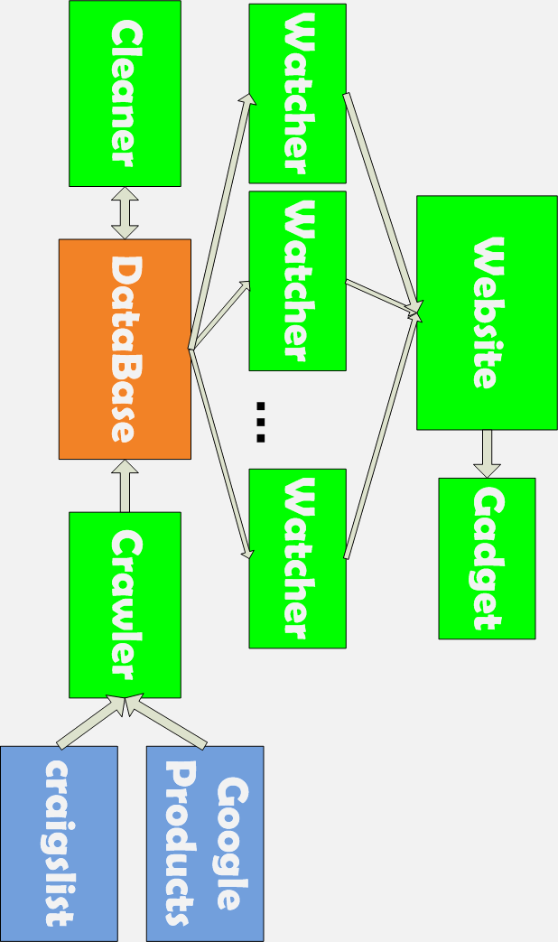
Analysis of the Review Finder (RF)

Here are some examples of the ReviewFinder in action.

Legend: Craigslist posting title
Product RF found reviews for (correct)
Product RF found reviews for (incorrect) matched words in bold

Bose Acoustimass 5.1 Speakers
Bose Acoustimass 10 Series IV 5.1 CH home theater speaker sys

Samsung 40" LED 1080p 120Hz TOP MODEL
Samsung - UN40B6000 - 40&quot; LCD TV - 1080p (FullHD)

Cordless Home Phone w/Digital Answering Machine
Bissell 1719 Cordless Rechargeable Spot Lifter Handheld Deep Cleaner

New Zune 120 GB Black with Home A/V Adapter
Microsoft Zune 120 GB Digital player radio Black

Garmin nuvi 1200
Garmin ni 1200 Hiking, automotive GPS receiver - TFT - 320 x ...

25 inch Orion Color TV with stand
Hardware House Madrid 25 Inch x 20 Inch Antique Bronze Chandelier ...

Newer Business Fax Machine
How to get your competition fired (without saying anything bad ... [Book]

3 12 inch hx2 subs
Halo 3 Master CHIEF 12 Action Figure

Nikon coolpix s220 trade for att phone
Nikon Coolpix S220 10 MP Digital Camera (Plum)

We find reviews by entering the entire title into google products and then searching the resulting page for text like “1.5 stars 25 reviews”. If we cannot find reviews on the resultant page, we drop off the last word and try again. For example;

try Iphone with carrying case nothing found
try Iphone with carrying nothing found
try Iphone with nothing found
try Iphone reviews found

Even with this simple and admittedly stupid method, we can find the correct reviews for 30% of postings. This is pretty good considering that we found that only 40% of craigslist posting titles had products in them that were specific enough to find reviews for.

Here are some approximate metrics.

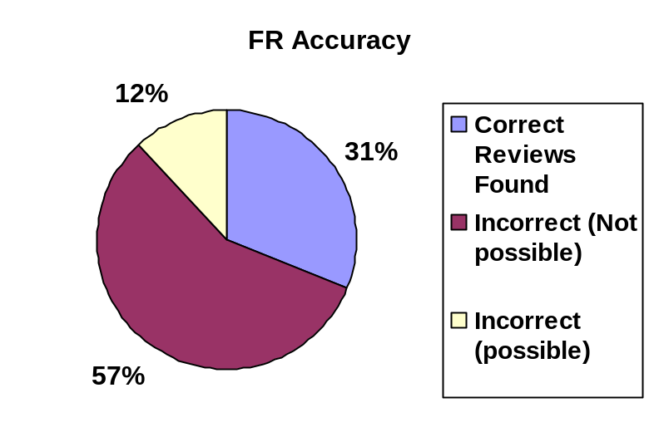

Sometimes a correct review is impossible to find because the product title is too generic. An example of such is the posting title “tv”. Other times, the reviews found are wrong even when the title holds all the data necessary to find the correct reviews.

There are many possible improvements on this system. We could remove intermediary words (the, and, a, of) to help the matching. We could also check that the title of the found review is a substring of the title of the craigslist posting and vise versa. We could also look for the subjects or nouns of the title. Its certain that the product isn’t a verb.
Appendices

Work load split: Henry and Rohith worked on the front end website and the Review Finder (db.php, ajax.js, index.html, findreview.java), Abhinav worked on the integrating the google maps functionality into the website and Riley worked on the back end (crawler.java, cleaner.java, query.java, wget.java). There was a problem dynamic in that Abhinav still worked full-time and it was hard for the rest of the group to meet up with him.

External-Code: Although we don’t use external code at a function level, we use craigslist, google maps, and google products to get all of our data.

Instructions: see readme.txt

